Garden Arts for Adults

with Robin K. Johnson

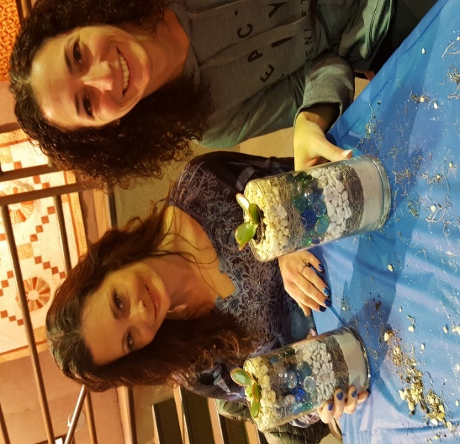 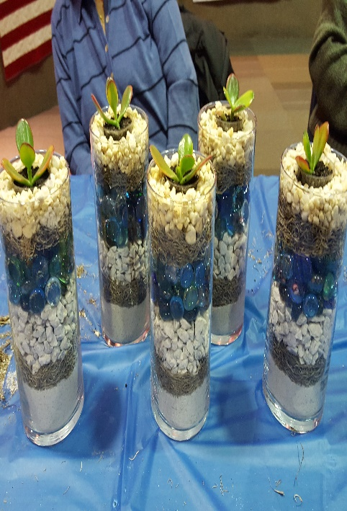 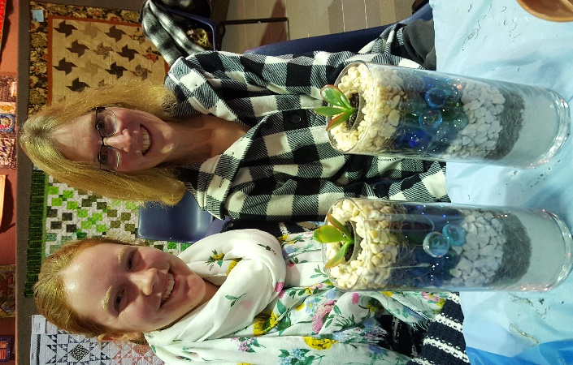

Layered Succulent Terrariums

Come join Garden Arts for Adults to make your own terrific Succulent Terrarium! Design your planter with glass beads, garden rocks, dried mosses and more. Learn about these interesting varieties of low maintenance plants that are easy to make & care for. Gardening made easy!!

When: June 6th Time: 6:30-7:30